Your Full Name
Professor Terry B. Ewell
MUSC 355
Date
Your Title
Your AI Picture
Figure 1. AI, “Title.”

End Notes (Not Required)

Works Cited
Citations must be presented in alphabetical order. Identify academic (in print or peer-reviewed) works with “Academic” at the end. Minimum of 10 citations, 4 academic, for an “A.” Citations are single-spaced here.

Templates:
AI. “Title.” Prompts: . URL. Accessed [Date]. Example: Bing Copilot. “Ledger Line.” Prompt: Ledger lines in music. https://www.bing.com/. Accessed 12 Jan. 2024.
Website or Video Author. “Website or Video Title.” URL. Accessed [Date].
Also, see the course bibliography for examples.

Do not Delete:
Instructions
This paper is written on the scenarios presented in Journal 13.
Remember that the paper needs to follow the proper format and contain a bibliography or references. You may use the same citations for both papers in Units 14-15, but I suspect you might find some additional references when you look at summaries from others in your group. You are advised to improve your citations or references for the Solutions Paper (the last paper) for a better grade!
You must use the proper template and citations. Observe carefully the format of the template and match it. Also review the materials on the paper webpage.
Avoid personal statements with words such as “I,” “me,” “my opinion,” etc. The focus should be on the analysis of the project, not self-reflection.
An abstract is not required for the papers in this course.
Final paper with Part 1 (Summaries Portion) and Part 2 (Solutions Portion) of the Paper. Total paper, minimum 1,000 words, maximum 2,000 words without citations and notes. For this paper, resubmit (copy and paste) the summaries paper (Journal 13) at the beginning of this final paper. Revise this portion to address the issues in my comments. Then continue by providing solutions and explanations with supporting citations.
Explain why your solutions are the best way to proceed. Refer to items presented in your prior summary paper. the bibliography and references should include all that was presented in the summary paper and additional items. You may add resources found by other group members to the bibliography and references. However, your solutions must be your own.
Supply a suitable concluding paragraph.
The file should be labeled: "LastnameFirstname_Final" (Example: EwellTerry_Final).
Submit this paper to your personal DropBox folder.
Personal Folder: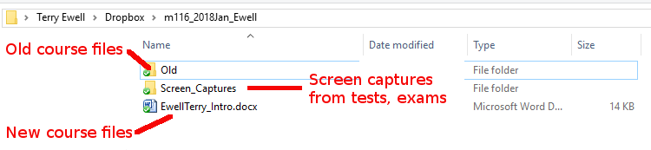

Rubric for Scenarios Summary and Solutions—Full Paper (Final)

Comments on your assignment:

Criteria | Max mark | Your mark | Your  grade | F grade  (F) | D grade  (D) | C grade  (C) | B grade  (B) | A grade  (A)
 |  |  |  | 0% to 59% | 60% to 69% | 70% to 79% | 80% to 89% | 90% to 100%
Title, Introductory, and Concluding Paragraphs | 10 |  |  | Not included or incorrect | Not complete or poorly presented | Lacking material | Good, but more better solutions were available | Well presented
Summary and Solutions | 30 |  |  | Not included or incorrect | Not complete or incorrect information | Lacking details | Good, but more information was available | Complete with accurate information
Format of Citations | 10 |  |  | Citations are not included | Frequently missing and/or not in correct style | Citations are occasionally missing and/or not in correct style | A few citations are occasionally and/or not in correct style | Citations are present for all key points and in correct style
Works Cited | 10 |  |  | Not included or incorrect | Less than 6 references or incorrect information or none in print | At least 6 references with 2 academic OR  no academic citations indicated. | At least 8 references with 3 academic citations | At least 10 references with 4 academic citations.
Overall quality of the paper | 40 |  |  | The document is not submitted or does not meet the level expected for 300-level work at Towson University. | The document has serious flaws in presentation, critical thinking, mechanics, rigor, and/or creativity. Only some of the goals and objectives are met in the document. | The document has some significant flaws in presentation, critical thinking, mechanics, rigor, and/or creativity. It barely meets the required goals and objectives. | The document is less cohesive in critical thinking than that of an “A” document. The document is well written, and goals are accomplished, but with less rigor, sophistication, or creativity than in an “A” document. There may be some mechanical errors. | The document reveals critical thinking in the application of principles presented in online lectures, discussions, and readings, as well as the student’s own research on the topic. Goals and objectives are clear and are clearly met in the final product
Mislabeled file -5  Wrong Template or missing rubric -5 |  | -0
Total | 100 | F8
Percentage | 100% | F8
 | 0 | F8
Grade for this assignment |  |  | F8

