Your Full Name
Professor Terry B. Ewell
MUSC 355
Date
Journal 9
A. This week I studied this number of hours for the course:
1___, 2___, 3 ___ , 4 __, 5 ___, 6 or more ____

B. I prepared for the final paper in the course by doing these things (provide details, personal language allowed):

1) Examining the requirements for the final paper:

2) Looking at the last readings in the course:

3) Examining my schedule and figuring out when I will be studying:

4) Cut and paste here the requirement for the final paper. It starts under the “Do not Delete:” section linked in Unit 14-15.

C. Report on the contributions of each student in your group. Avoid references to yourself, but you may refer to the work of the other students. Use non-personal academic language by refering to the student’s work not the person.
Student Name 1:
The grade (A, A-, B+, B, etc.) you would give to the student's contribution to the discussion:
Discuss the contribution of the student to the discussion and their contributions by email or Dropbox. How helpful was the information supplied by the student? How much effort did the student put into the discussion?
Student Name 2:
Student Name 3, etc.:
Do not rate yourself.

DO NOT DELETE
Complete the paper as directed above.
Label the file as LastnameFirstname_Journal9 (Example EwellTerry_Journal9). Place it in the main directory of your personal Dropbox folder for the course.
Personal Folder: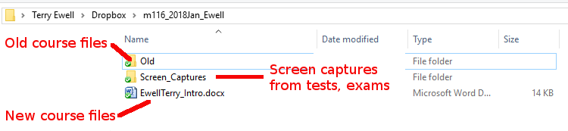

Comments on your assignment:

Criteria | Max mark | Your mark | Your  grade | F grade  (F) | D grade  (D) | C grade  (C) | B grade  (B) | A grade  (A)
 |  |  |  | 0% to 59% | 60% to 69% | 70% to 79% | 80% to 89% | 90% to 100%
Indication by the student of hours studied for the week. | 10 |  |  | No indication | Less than 4 | 4 or more | 5 or more | 6 or more
Report on Student participation | 40 |  |  | Not included or incorrect | Not complete or incorrect information | Lacking details | Good, but more information was available | Complete with accurate information
Information on readings, requirements | 40 |  |  | Not included or incorrect | Not complete or incorrect information | Lacking details | Good, but more information was available | Complete with accurate information
Overall quality of the paper | 10 |  |  | Incomplete or not submitted journal | The journal was inadequate. | The journal was complete but missing some details. | The journal was complete with some details. | The journal was complete with good details.
Mislabeled file -5  Wrong  Template or missing rubric -5 |  | -0
Total | 100 | F8
Percentage | 100% | F8
 | 0 | F8
Grade for this assignment |  |  | F8

