Your Full Name
Professor Terry B. Ewell
MUSC 355
Date
Journal 7
A. This week I studied this number of hours for the course:
1___, 2___, 3 ___ , 4 __, 5 ___, 6 or more ____
B. Using academic, non-personal language with citations, provide short summaries of the readings and websites from the course readings.

1) Moser, chapter 14

2) LECTURE: Copyright and Remixing in the Digital Age, Part 1

3) LECTURE: Copyright and Remixing in the Digital Age, Part 2,

4) Tarleton Gillespie, lecture 1

5) Tarleton Gillespie, lecture 2

6) Tarleton Gillespie, lecture 3

C. Copy and paste here the instructions for unit 9 Group Research, including the questions each group must answer

D. Detail here how you contributed to your group research and directly addressed the instructions and questions. (Personal language allowed)

E. Create a screencast (video recording of your computer screen) where you discuss your contributions to the group research. Time limit 3-5 minutes.

The software I used for the screencast is: ________________
The location of my screencast is: _________________ (Dropbox, URL with YouTube, Screencast-O-matic).
Label the file as LastnameFirstname_Journal7Video (Example EwellTerry_Journal7Video). Place it in the main directory of your personal Dropbox folder for the course.

Works Cited
Citations must be presented in alphabetical order. Identify academic (in print or peer reviewed) works with “Academic” at the end. Citations are single-spaced here.

Templates:
AI. “Title.” Prompts: . URL. Accessed [Date]. Example: Bing Copilot. “Ledger Line.” Prompt: Ledger lines in music. https://www.bing.com/. Accessed 12 Jan. 2024.
Website or Video Author. “Website or Video Title.” URL. Accessed [Date].
Also, see the course bibliography for examples.

DO NOT DELETE
Complete the paper as directed above.
Label the file as LastnameFirstname_Journal7 (Example EwellTerry_Journal7). Place it in the main directory of your personal Dropbox folder for the course.
Personal Folder: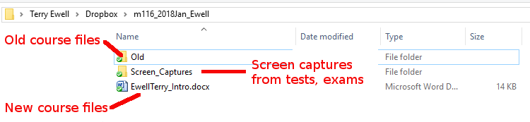

Comments on your assignment:

Criteria | Max mark | Your mark | Your  grade | F grade  (F) | D grade  (D) | C grade  (C) | B grade  (B) | A grade  (A)
 |  |  |  | 0% to 59% | 60% to 69% | 70% to 79% | 80% to 89% | 90% to 100%
Indication by the student of hours studied for the week. | 10 |  |  | No indication | Less than 4 | 4 or more | 5 or more | 6 or more
Journal completion | 20 |  |  | Not included or incorrect | Not complete or incorrect information | Lacking details | Good, but more information was available | Complete with accurate information
Screencast | 20 |  |  | Not included or incorrect | Not complete or incorrect information | Lacking details or with technical problems | Good, but with a few minor issues. | Complete with accurate information
Non-personal academic writing | 10 |  |  | Does not meet standards for a university course. | Significant problems with language: spelling, personal references, grammar, etc. | More problems with language: spelling, personal references, grammar, etc. | A few problems with language: spelling, personal references, grammar, etc. | Excellent use of language
Citations | 10 |  |  | Citations are not included | Citations are frequently missing and not in the correct style | Citations are occasionally missing or not in correct style | A few citations are occasionally missing or not in correct style | Citations are present and in correct style
Overall quality of the paper | 30 |  |  | The document is not submitted or does not meet the level expected for 300-level work at Towson University. | The document has serious flaws in presentation, critical thinking, mechanics, rigor, and/or creativity. Only some of the goals and objectives are met in the document. | The document has some significant flaws in presentation, critical thinking, mechanics, rigor, and/or creativity. It barely meets the required goals and objectives. | The document is less cohesive in critical thinking than that of an “A” document. The document is well written, and goals are accomplished, but with less rigor, sophistication, or creativity than in an “A” document. There may be some mechanical errors. | The document reveals critical thinking in the application of principles presented in online lectures, discussions, and readings, as well as the student’s own research on the topic. Goals and objectives are clear and are clearly met in the final product
Mislabeled file -5  Wrong  Template or missing rubric -5 |  | -0
Total | 100 | F8
Percentage | 100% | F8
 | 0 | F8
Grade for this assignment |  |  | F8

