Your Full Name
Professor Terry B. Ewell
MUSC 355
Date
Journal 14
A. This week I studied this number of hours for the course:
1___, 2___, 3 ___ , 4 __, 5 ___, 6 or more ____
B. Report D (Scenarios work) Avoid references to yourself, but you may refer to the work of the other students. Use non-personal academic language by refering to the student’s work not the person.
Report on the contributions of each student (except yourself) in your group. Supply the following information for each student in alphabetical order by their last name.
Student Name 1:
The grade (A, A-, B+, B, etc.) you would give to the student's contribution to the discussion:
Discuss the contribution of the student to the discussion and their contributions by email or Dropbox. How helpful was the information supplied by the student? How much effort did the student put into the discussion?
Student Name 2:
Student Name 3, etc.:
Do not rate yourself.

DO NOT DELETE
Label the file as LastnameFirstname_Journal14 (Example EwellTerry_Journal14. Place it in the main directory of your personal Dropbox folder for the course.
Personal Folder: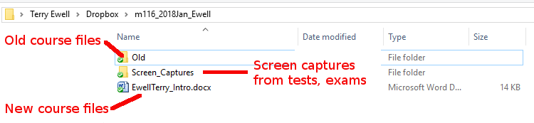

Comments on your assignment:

Criteria | Max mark | Your mark | Your  grade | F grade  (F) | D grade  (D) | C grade  (C) | B grade  (B) | A grade  (A)
 |  |  |  | 0% to 59% | 60% to 69% | 70% to 79% | 80% to 89% | 90% to 100%
Indication by the student of hours studied for the week. | 10 |  |  | No indication | Less than 4 | 4 or more | 5 or more | 6 or more
Report D | 80 |  |  | Not included or incorrect | Not complete or incorrect information | Lacking details | Good, but more information was available | Complete with accurate information
Appropriate academic writing | 10 |  |  | Does not meet standards for a university course. | Significant problems with language: spelling, personal references, grammar, etc. | More problems with language: spelling, personal references, grammar, etc. | A few problems with language: spelling, personal references, grammar, etc. | Excellent use of language
Mislabeled file -5  Wrong  Template or missing rubric -5 |  | -0
Total | 100 | F8
Percentage | 100% | F8
 | 0 | F8
Grade for this assignment |  |  | F8

