Your Full Name
Professor Terry B. Ewell
MUSC 105
Date
Journal 6
A. This week I studied this number of hours for the course:
1___, 2___, 3 ___ , 4 __, 5 ___, 6 or more ____
B. Using academic and non-personal language provide a short summary of the items listed below. Each summary must include an in-text citation and be double-spaced. Complete citations are given at the end of the journals. AI summaries are allowed with proper citations.
Catherine Schmidt-Jones. “Key Signatures.” Music Fundamentals 1, Chapter 7.

Catherine Schmidt-Jones. “Major Keys and Scales.” Music Fundamentals 1, Chapter 8.

Wikipedia. "Circle of 5ths"--view the beginning chart and text only.

Works Cited
Citations must be presented in alphabetical order. Identify academic (in print or peer-reviewed) works with “Academic” at the end. Citations are single-spaced here.

Templates:
Website or Video Author. “Website or Video Title.” URL. Accessed [Date].
AI. “Title.” Prompts: . URL. Accessed [Date]. Example: Bing Copilot. “Ledger Line.” Prompt: Ledger lines in music. https://www.bing.com/. Accessed 12 Jan. 2024.

Do not Delete:

Post your file in your Personal Dropbox folder as follows:

YourLastnameFirstname_Journal6.docx. For instance: EwellTerry_Journal6.docx. (Microsoft Word automatically adds “.docx”—Double check in Dropbox that the file name is correct.
Personal Folder: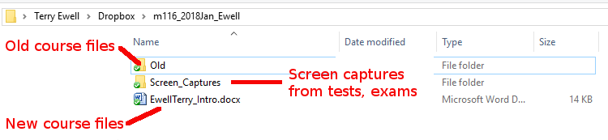

Comments on your assignment:

Criteria | Max mark | Your mark | Your  grade | F grade  (F) | D grade  (D) | C grade  (C) | B grade  (B) | A grade  (A)
 |  |  |  | 0% to 59% | 60% to 69% | 70% to 79% | 80% to 89% | 90% to 100%
Indication by the student of hours studied for the week. | 10 |  |  | No indication | Less than 4 | 4 or more | 5 or more | 6 or more
Journal completion | 20 |  |  | Not included or incorrect | Not complete or incorrect information | Lacking details | Good, but more information was available | Complete with accurate information
Non-personal academic writing | 30 |  |  | Does not meet standards for a university course. | Significant problems with language: spelling, personal references, grammar, etc. | More problems with language: spelling, personal references, grammar, etc. | A few problems with language: spelling, personal references, grammar, etc. | Excellent use of language
Citations | 10 |  |  | Citations are not included | Citations are frequently missing and not in the correct style | Citations are occasionally missing or not in correct style | A few citations are occasionally missing or not in correct style | Citations are present and in correct style
Overall quality of the paper | 30 |  |  | The document is not submitted or does not meet the level expected for 300-level work at Towson University. | The document has serious flaws in presentation, critical thinking, mechanics, rigor, and/or creativity. Only some of the goals and objectives are met in the document. | The document has some significant flaws in presentation, critical thinking, mechanics, rigor, and/or creativity. It barely meets the required goals and objectives. | The document is less cohesive in critical thinking than that of an “A” document. The document is well written, and goals are accomplished, but with less rigor, sophistication, or creativity than in an “A” document. There may be some mechanical errors. | The document reveals critical thinking in the application of principles presented in online lectures, discussions, and readings, as well as the student’s own research on the topic. Goals and objectives are clear and are clearly met in the final product
Mislabeled file -5  Wrong  Template or missing rubric -5 |  | -0
Total | 100 | F8
Percentage | 100% | F8
 | 0 | F8
Grade for this assignment |  |  | F8

